REQUIREMENTS FOR ADMISSION AT THE UNIVERSITY OF CELAYA

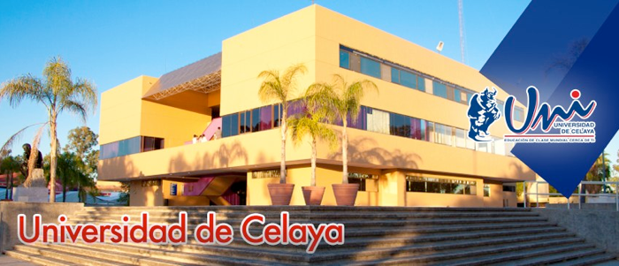

Study in Celaya, a city of 490,000 inhabitants, with a privileged location and located in the touristic corridor of upper central Mexico, surrounded by the best natural sites, the most beautiful historical sites (several are world heritage sites) and an area of vibrant economic and business activity.

Get to know our academic offer in our web site: www.udec.edu.mx

Semester beginning date: August 4th 2014.
Semester end date: November 28th 2014.

STEP 1 – Turn in the initial documents by April 30th 2014

- Admission Form (available online)
- Academic transcripts (with a translated copy in English)
- Copy of passport with

Contact the Mexican embassy regarding visa requirements. Generally no visa is required if the student stays no more than 180 days. Nevertheless and if necessary, a letter of acceptance from our institution will be needed in order to obtain the student visa.

Note: these documents should be sent via email to internacional@udec.edu.mx

STEP 2 – Letter of acceptance
Once covered the previous requirements, the University of Celaya will give you a letter of acceptance.

STEP 3 – Paying for tuition and accommodation for one term:

Tuition fee: 3,000 USD( As exchange students,you don’t need pay the tuition fees)
Accommodation fee: 1,750 USD

This payment can be made through your university by the deadline: June 30th 2014.

STEP 4 – Upon arrival at the University of Celaya
1. - We will provide you with an introductory session on Monday August 4th 2014 in the rectory building.

2. - Turn in the original application for admission and a copy of migratory permit (the one received in the airport) to the admissions office in the rectory building.

3. - Please remember that you need to buy health insurance with international coverage. A copy of this policy should be turned in to the Internationalization Area upon arrival.

4. - If it applies, once arrived in Celaya, the student should attend the National Immigration Institute to register. This facility is very close as it is located in nearby San Miguel de Allende (30 minutes away).

5. - All migratory documents of the international student should be turned in to the admissions office no later than 2 months after arrival

To arrive to Celaya:
From México City´s Airport you can take a bus towards Celaya or take one to the city of Queretaro. From there you can take a second bus to Celaya (only 40 minutes away). The time length of travel is about 4 hours.
Take a flight directly to the city of Queretaro or León and take a cab to the city of Celaya.

Additional information:
Here is some additional information (per month) on costs of living:

 | Approximated costs
 | MXN | USD
Food | 3000 | 220
Transportation | 600 | 40
Leisure | 2000 | 150
Total (monthly) | 5,600 | 410

